IFT6758 Project: Hockey Primer

If you’ve never watched hockey or aren’t sure what you need to know, this guide is for you! There are tons of resources available online, but for brevity we try to outline here all of the things that one needs to know about hockey to get going on the project. If anything is unclear, do not hesitate to add a comment to this document, or ask a question on Piazza as **we** **do not want you wasting time trying to understand mundane things about hockey**. This is a data science course, not a hockey course! There are no bad questions, we understand that not everyone may have been exposed to hockey.

In the text that follows, we attempt to highlight all hockey terminology or jargon by **bolding** relevant words; i.e. if a word is bolded, it is a common/formal hockey term.

**Summary Video** **2**

**Overview** **2**

**The Ice Rink** **3**

**Team Composition and Lines/Pairs** **4**

Hockey Sticks 7

**Gameplay** **7**

Faceoff 7

Goals 8

Hitting/Checking 9

Common Shots 9

Offside 10

Icing 10

**Penalties** **11**

Power Play, Penalty Kill, and Special Teams 12

Penalty Shot 12

**Hockey Season** **12**

Regular Season 12

Standings 13

Playoffs 13

Player stats 14

**Useful References** **15**

# Summary Video

It is recommended that you watch this first so you have an overall sense of the game before reading our more detailed overview of the game. It may be hard to follow all of the jargon and vocabulary without being exposed to it first (3m33s).

[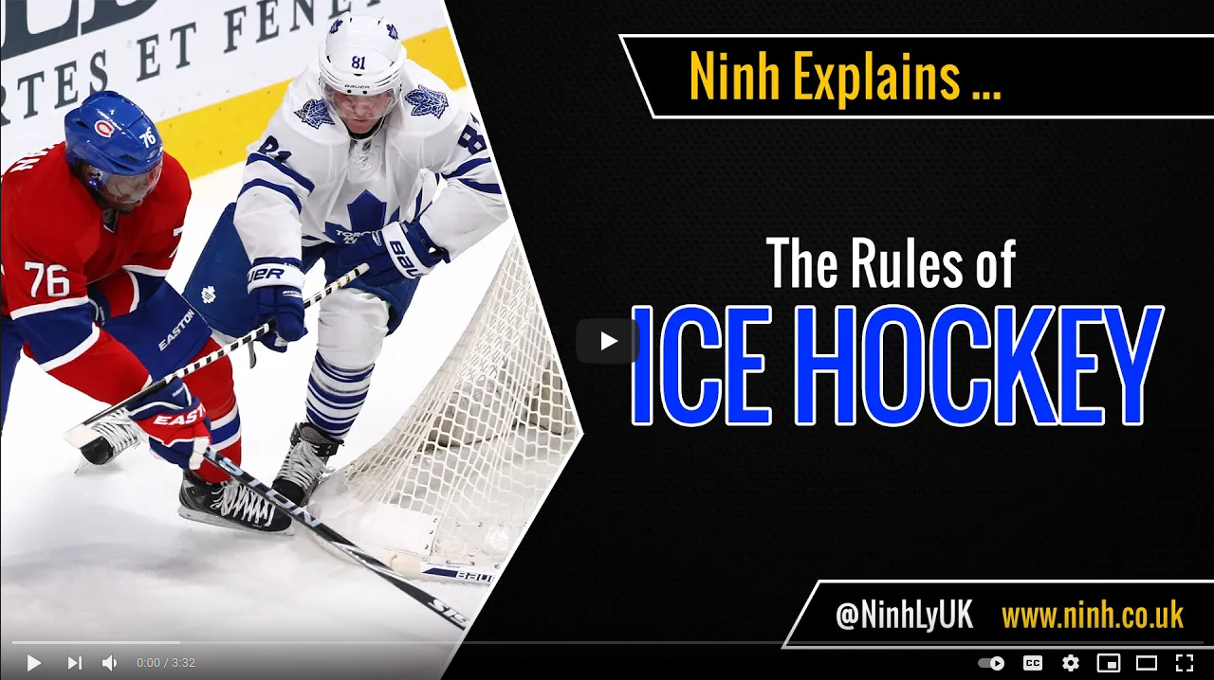](https://www.youtube.com/watch?v=nv2FUnHceqU)

URL: [**https://www.youtube.com/watch?v=nv2FUnHceqU**](https://www.youtube.com/watch?v=nv2FUnHceqU)

# Overview

Hockey is a team sport played on an ice rink between two teams, where the objective is to score more **goals** than the opponent by getting the **puck** (a small disk made of very dense rubber) into the opposing team's **net**. Each team has 20 skaters, with 6 skaters typically on the ice at once time. There are three distinct categories a skater may take: a **forward**, **defensemen**, and **goaltender (goalie)**. These categories reflect what kind of role these players may have on the ice. **Forwards** typically play the most active role when “attacking” an opponent’s **zone** in an attempt to score. **Defensemen** typically stay further back in the opponent’s **zone**, and are responsible for defending their own **zone** when the opposing team attempts to enter their own **zone**. **Goalies** wear special equipment and protect their net from the opposing teams scoring attempts. On the ice, the two teams wear coordinated uniforms which depend on if they are playing either a **home** or **away** game. Every team has a **home arena**; when they are playing at **home**, they are referred to as the **home team** and typically wear coloured **jerseys** which reflect their team colours. When they are playing in another arena, they are playing an **away** game and wear white **jerseys**.

A hockey game is broken into three 20 minute **periods** between which there are 15 minute breaks. Teams switch sides at the end of every **period**. If at the end of 60 minutes one team has a higher score than the other, that team wins the game. If not, the game goes into sudden death **overtime**, where the first goal wins the game (there are no draws!). The rules for **overtime** can vary depending on if this is a **regular season** game or **playoff** game, but this will be discussed in the “*Hockey Season*” section. At the start of each **period**, the **puck** is dropped at **center ice** for a **faceoff**, where two players attempt to gain **possession** of the **puck**. From there, the game plays out until there is a **stoppage**, which is an interruption in the play such as a **penalty** or **goal** (discussed later). During a **stoppage**, the game timer is paused, so the game is guaranteed to have at least 60 minutes of active gameplay. To resume play, another **faceoff** occurs. The location of the **faceoff** depends on the circumstances of the **stoppage**, i.e. was it a **penalty**? Was it **icing** (discussed later)? Was it a **goal**? Did the **goalie** stop the play? From there teams once again resume play and attempt to score goals on the opposing team’s **net**. At the end of each **period**, play is stopped immediately.

Hockey is a very intense sport, and as a result players frequently swap out to rest; there are no limitations on how many substitutions each team has. Substitutions can occur during play (i.e. without a stoppage) - this is referred to as a **line change**. **Forwards** are usually kept in groups of 3 (referred to as a **line**), and **defensemen** are usually kept in groups of 2 (referred to as a **pair**). The only exception is the **goalie,** who typically stays in **net** for the whole game. There are two common scenarios in which a goalie may not play a whole game:

1. They get **pulled** in favour of the **backup** goalie. This usually happens if the **goalie** is performing poorly that night, such as letting in many goals or “easy” goals. This means that the original **goalie** comes off the ice and sits out while the **backup goalie** takes their place.
2. They get **pulled** for an extra skater, either a **forward** or **defensemen**. This may happen if the team is desperate to score a **goal** (eg. 2 minutes left in the game and the team is down by 1 goal), or under special circumstances involving a **delayed penalty** (more advanced rule which is detailed later).

Note that the rules only say that you can have a maximum of 6 skaters on the ice at any given time, not of what kind of players are required to be on the ice. This means that you are technically allowed to have 6 **forwards** on the ice, but in practice this rarely happens.

# The Ice Rink

There are a few different types of hockey rink standards (such as the NHL and IIHF), but for the purposes of this course we will only concern ourselves with the NHL standard, which requires the same rink dimension for every rink that NHL teams may play in. The rink is 200 by 85 feet (60.96 m × 25.9 m) with a corner radius of 28 feet (8.5 m). Each **goal line** is 11 feet (3.4 m) from the end of the rink. NHL **blue** **lines** are 75 feet (22.9 m) from the end of the rink, and 50 feet (15.2 m) apart.

The rink has a number of markers painted onto the ice.

* The center **red line** cutting the rink in half; this is important in **icing** calls (discussed later)
* Two red **goal lines,** drawn along each team’s net, which are important in **icing** calls
* The two **blue lines** which define each team’s **zone**. The **offensive zone** is the zone between the **blueline** and the nearest end of the rink containing the opposing team’s **net**, the **defensive zone** is your equivalent zone, and the **neutral zone** is the area between the two **bluelines**. The **bluelines** are important in ensuring a play is not **offside** (discussed later).
* Nine **faceoff dots** which are locations where a **faceoff** may occur. There is one at **center ice**, two in the **offensive zone**, two in the **defensive zone**, and four in the **neutral zone**.
* A blue **goal crease** which defines the area in which a **goalie** must not be impeded with by other players (i.e. **goaltender interference**)

There are two **nets** or **goals**, one for each team. The opening of the **net** is placed along the **goal line**, and there is a bit of space behind the goals that players are allowed to play in. Finally, the entire rink is surrounded by **boards**, and with the exception of the **offside** rule (discussed later), players can skate anywhere on the ice.

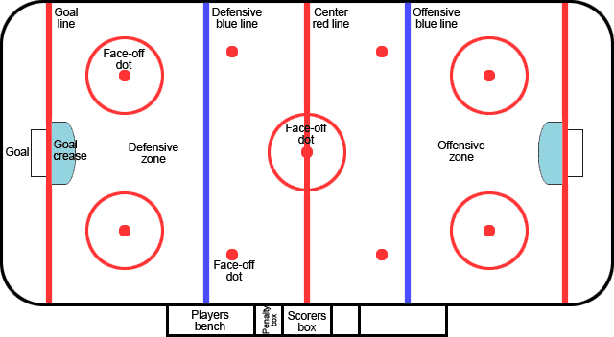

*A complete ice rink with most of the relevant markings drawn.*

# Team Composition and Lines/Pairs

For a given game, each team must have a 20-man team, typically of 12 **forwards**, 6 **defensemen**, a **starting goaltender** and a **backup goaltender**.

The 12 **forwards** are further broken up into 4 lines consisting of three players: a **left wing**, **center**, and **right wing**. These players typically have different duties on the ice, but their strategies vary per player’s playstyle or a team’s overall strategy. In general, **centers** are considered to have the most responsibility on the ice, tasked with covering much of the ice as well as bearing significant defensive responsibilities. They are often expected to **make plays** (i.e. initiate plays) which requires them to “read” the play well and have strong passing abilities. They typically score less **goals** than wingers but have more **assists** due to this role. **Left/right wingers** tend to have the most aggressive roles, playing deeper in the offensive zone than centers.

The 6 **defensemen** are deployed in **pairs** (**left/right defense**), and are primarily tasked with preventing the opposing team from scoring. As a result, they typically stay near the **offensive blueline** when in the **offensive zone**, and go deeper into their own **defensive zone** to prevent **scoring chances**.

Typically, **lines** and **pairings** are referred to by some number, i.e. **1st line**, **2nd line**, **3rd line**, **4th line** for the **forwards**, and **1st pairing, 2nd pairing**, and **3rd pairing** for the **defensemen**. The smaller numbers typically refer to higher skilled players, with greater expectations placed upon them. For example, a team’s **1st line** may be the most relied upon group of **forwards** to score **goals**, whereas the **4th line** may be tasked with **checking** (discussed later) and wearing down the opponents rather than scoring. This is more of a colloquial definition however, as **lines** are often **“juggled”** (i.e. players are swapped around) in an attempt to find players that have good chemistry with each other. This can lead to situations where previously low skill **4th line** players find themselves having great chemistry with players on the **1st line** and scoring way beyond what their historical performances may suggest. The same is true with **defensemen**, but because their primary objective is to prevent the opposition from scoring, less emphasis is placed on their offensive abilities.

The **goaltender** plays a special role in hockey, and stays in their net the whole game with a few exceptions. They are outfitted with a larger stick, a catching glove, and more protective padding to block pucks from entering the net. A team generally has a **starting goaltender**, which is their best **goaltender** that they expect to **start** most of their games with. Teams also have a **backup goaltender**, which often plays when the **starting goaltender** needs to rest or is injured. Again, humans are subject to huge variances in their performance and sometimes a **backup goaltender** finds themselves outplaying a **starting goaltender**, and supplanting them.

To help make this a bit more concrete, below is an example of a typical game-day roster. This was the Montreal Canadiens’ projected roster for Game 5 of the 2021 Stanley Cup Finals.

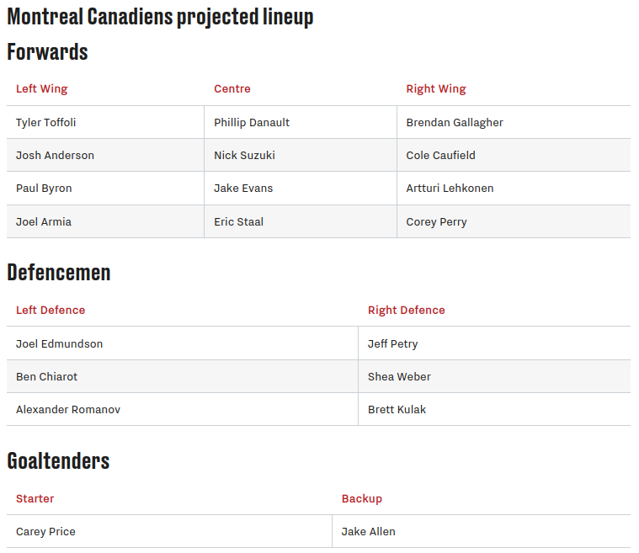

References:

* [Winger](https://en.wikipedia.org/wiki/Winger_(ice_hockey))
* [Center](https://en.wikipedia.org/wiki/Centre_(ice_hockey))
* [Defensemen](https://en.wikipedia.org/wiki/Defenceman)
* [Goaltender](https://en.wikipedia.org/wiki/Goaltender)

## Hockey Sticks

A slight aside on hockey sticks: players typically have a preferred handedness with their stick (i.e. they are left handed or right handed). This handedness impacts the shape of their stick and as a result which side they prefer to shoot the puck from. Because the stick blade is curved, this affects how a player might take a **faceoff** or shoot the puck in an attempt to score a **goal**. A player's handedness has a huge impact on plays because shooting on your **backhand** (i.e. from the back of the blade) is usually far weaker and less accurate than from the front of the blade. Players can use this information in strategic ways, such as trying to push attacking players off their **forehand** to their **backhand** when **defending**. This also plays a big role in how effective a defenseman may be along the boards, and as a result coaches often try to deploy **defensemen** on their strong side (i.e. a right handed **defensemen** on the right side). This could be an interesting feature to explore as the importance of handedness is always a source of debate in the hockey analytics community!

# Gameplay

## Faceoff

To begin **play** at the start of a **period** or after a **stoppage**, two players, one from each team, will line up and have a **faceoff** in an attempt to control the puck. The **puck** is dropped by an official, and then the players fight to control the **puck** and **play** begins.

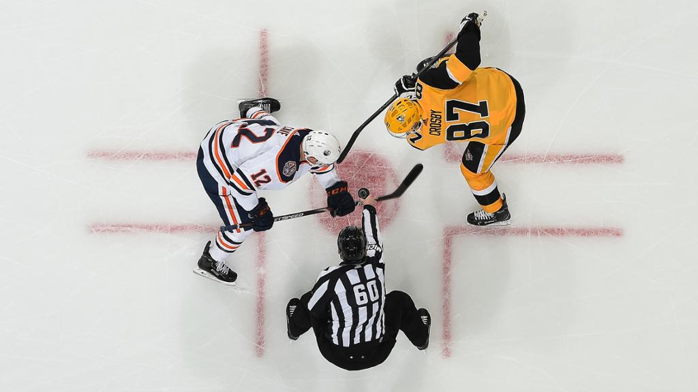

*A faceoff between two players*

## Goals

A goal is scored if the **puck** completely crosses the **goal line** in the opponents **net.** If the *entire* puck is not completely over the line, it does not count as a **goal.** **Goals** can be scored in a variety of ways, but there are a few restrictions as to what is and isn’t allowed. Specifically:

* A **goal** cannot be scored by a **stick** above the **crossbar** (top bar) of the **net**; this is known as a **high stick**.
* A **goal** cannot be *intentionally* kicked in by an opposing player’s **skate**, but incidental kicking is acceptable.
* Opposing players cannot make contact with the **goaltender** within their **goal crease** (the blue paint in front of the **net**). This is known as **goaltender interference**.

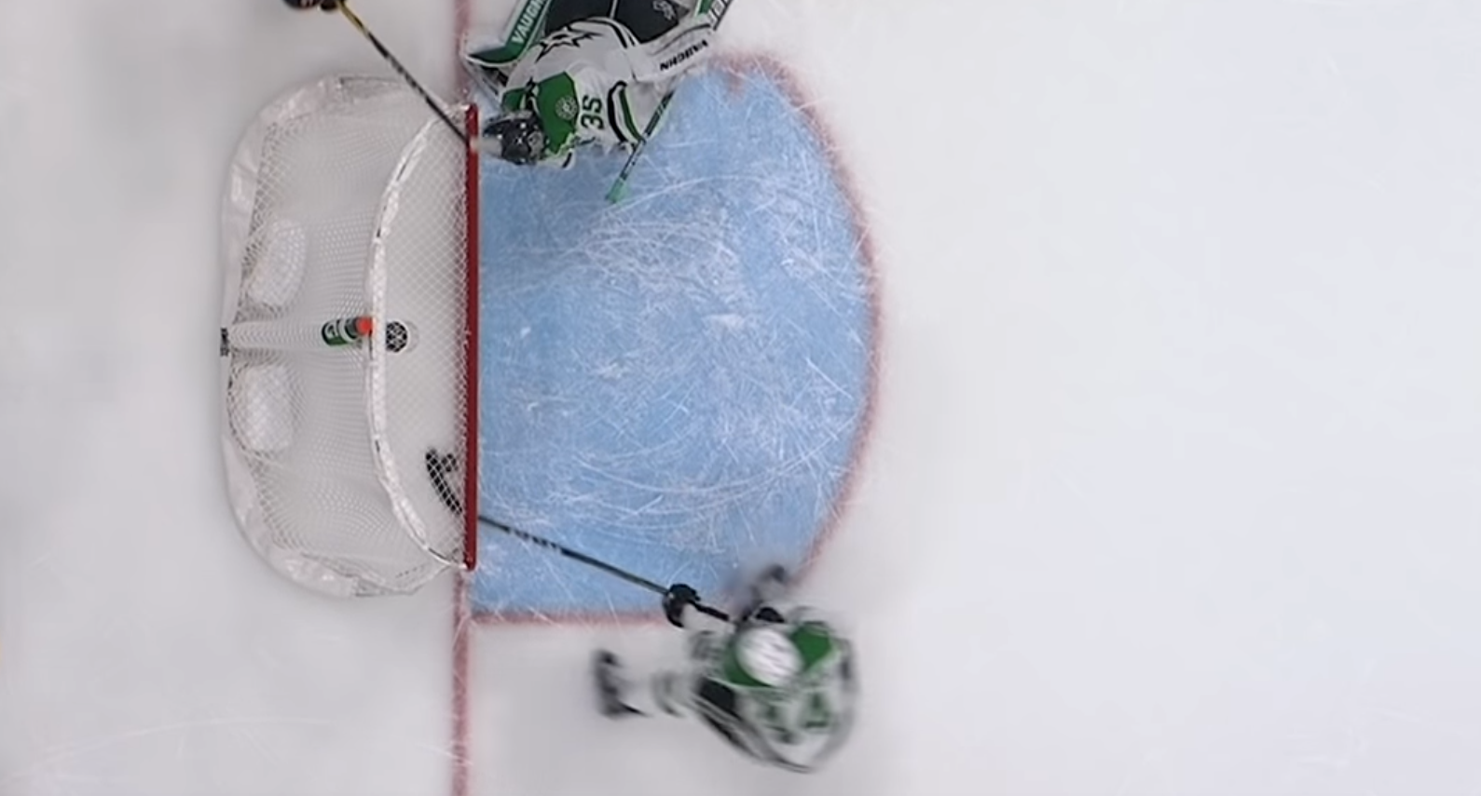

*Close, but no goal! The puck was not completely over the red line.*

When a team scores a **goal**, play resumes by taking a **faceoff** at **center ice**. **Goals** are one of the primary metrics tracked for each player over the course of a season, in addition to **assists** to a **goal**. The player who scored the **goal** is credited with the goal, while the last two teammates who touched the puck prior to the goal-scorer are rewarded with an **assist**. Both **goals** and **assists** count as **points** that a player accumulates over a season, and so the total number of **points** is simply the sum of **goals** and **assists**. The notion of **points** is discussed in the *Player Stats* section.

## Hitting/Checking

Contact is allowed in ice hockey, with certain restrictions as to how the contact is made. You don’t need to worry about these rules, but if you see the keyword **hit** or **check** in the dataset, this refers to a player making contact with another, typically in an attempt to disrupt the opponent from maintaining possession of the **puck**.

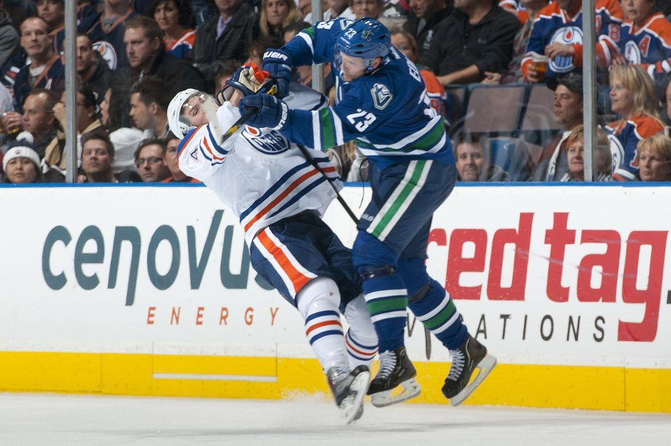

A more comprehensive list of **checking** types can be found [here](https://en.wikipedia.org/wiki/Checking_(ice_hockey)).

## Common Shots

Within the API, you are most likely to see four different types of shots: **wrist**, **snap**, **slapshot**, and a **backhand.** It is not important to understand the nuances between the different types of shots, however it is useful to understand the context in which they are typically used and some high level

* **Wrist shot**: typically the most common and accurate type of shot
* **Slapshot**: the classic stereotypical hockey shot with a big windup. It's very telegraphed and not very accurate, but one can get a lot of power in it. This is often used as a **one-timer**, which refers to taking a shot directly from a **pass** in a single motion rather than receiving the **puck** and taking a shot after.
* **Snap shot:** similar to a **wrist shot** but mixes a bit of the **slapshot** mechanics. It has a very quick release and results in a hard and accurate shot, but less hard than the **slapshot** and less accurate than a **wrist shot**.
* **Backhanders**: any shot taken from the backside of the stick blade. Usually very weak and inaccurate, but as a result they are often unpredictable. Players generally have much weaker **backhand** shots than the other kinds of shots, and as a result they are used when a player is trying to just throw the **puck** on net, or fool the **goaltender.**

Although not a shot, you may also see reference to a **tip in**; this is when a player redirects the **puck** into the net from another player’s shot using their stick.

## Offside

Players are not allowed to enter the **offensive zone** before a player carrying a **puck** enters the zone. This is to prevent players from waiting in the **offensive zone** while the **puck** is currently in the **defensive zone.** Entering the **offensive zone** before doing so results in an **offside** call which stops play and brings the **faceoff** out of the **offensive zone**. The most common occurrence of this is if two players on the same team are trying to enter the **offensive zone**, and the player carrying the **puck** is slightly behind the other. For example, the play in the figure below is considered offside if the **center** (C) is carrying the **puck**, but **onside** (legal) if the **left wing** (LW) is carrying the **puck**.

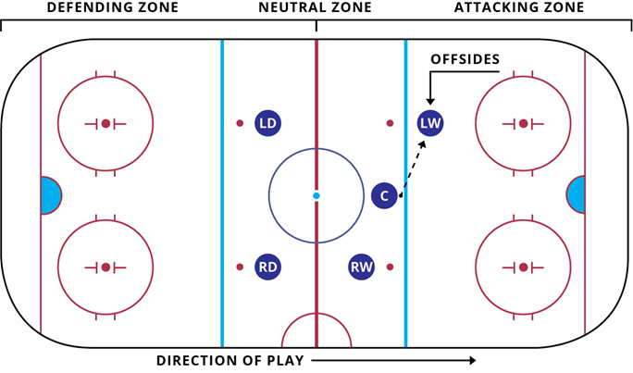

## Icing

**Icing** is when a player on his team’s side of the **center line** shoots the **puck** all the way down the ice and it crosses the **red goal line** at any point (other than the goal). **Icing** is not permitted when teams are at **equal strength** or on the **power play** (discussed later). When this occurs, **play** is stopped and the **puck** is returned to the other end of the ice for a **faceoff** in the offending team’s zone. **Icing** is not called when:

* The goalie leaves the **crease** to play the **puck**, even if he does not touch the **puck**
* An official rules an opposing player could have played the **puck** before it crossed the **red goal line**
* An official may waive off the **icing** call if he deems it was an attempted **pass**
* A team is on the **penalty kill**, i.e. playing **shorthanded** (discussed in the next section)

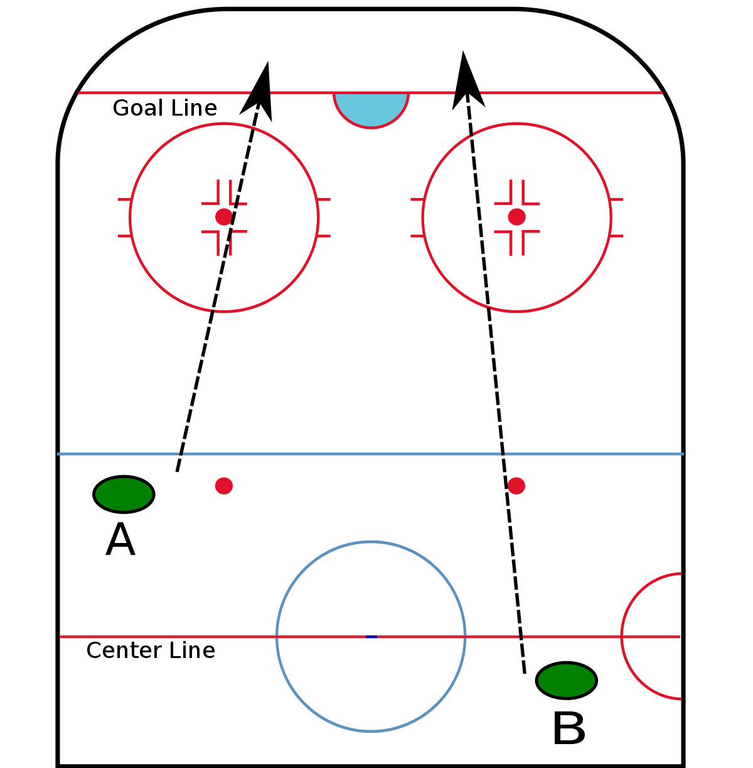

*In this example, player A can shoot the puck down the ice with no consequence, while player B would result in an* ***icing*** *call.*

# Penalties

A player’s action that violates the rules may be given a **penalty** at the discretion of the officials. There are three types of **penalties**:

* **Minor:** the player sits in the **penalty box** for 2 minutes while their team plays **shorthanded** (i.e. down a player). If the opposing team scores, the **minor penalty** expires and the team is no longer **shorthanded.**
* **Major**: the player sits in the **penalty box** for 5 minutes while their team plays **shorthanded**. Unlike the **minor** however, the **penalty** does not expire if the opposing team scores.
* **Misconduct:** the player is removed from the game for 10 minutes, however the team does not play **shorthanded.**

Specific details on **penalties** are not super important, but more details on the different types of infractions can be found [here](https://en.wikipedia.org/wiki/Penalty_(ice_hockey)#List_of_infractions). Note that multiple players can serve **penalties** simultaneously, but a team will have no fewer than 4 skaters including the **goalie** on the ice at a given time (i.e. down two players, playing 3 on 5. It can be confusing because the **goalie** is not usually included in this count. ).

Note that a **penalty** can be **delayed** if an infraction occurs but the non-offending team is in control of the puck. This is to give them a chance to score a **goal** rather than interrupting play. As soon as the offending team touches the **puck**, the play is stopped and the offending player is removed from the ice to serve his **penalty**. Teams usually **pull their goalie** during a **delayed penalty** call to play **six on five (6-5)**, because there is little risk of the opposing team scoring as they cannot control the **puck** at all. There have been cases where the non-offending team somehow ended up scoring on their own goal, which is pretty embarrassing for the team.

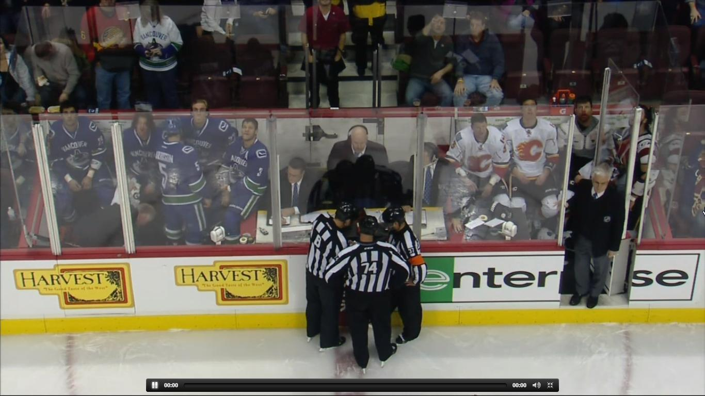

*Eight penalties in the first minute of the game...*

## Power Play, Penalty Kill, and Special Teams

When a team has more players on the ice than the other due to **penalties**, they are on the **power play**. The team playing **shorthanded** is on the **penalty kill**. Teams typically assemble a different group of players than the typical deployments of three **forwards** (LW, C, RW) and two **defensemen** when playing at **even strength.** They may play their most dangerous offensive forwards together, or swap a **defenseman** for a **forward**. Similarly, the team on the **penalty kill** may play their most defensive players to try to prevent a goal. In either case, these groups are called **special teams.**

## Penalty Shot

If a player is on a **breakaway** (i.e. a player has no defending players between himself and the **goaltender**) with a clear **scoring chance** and is interfered with because of a foul committed by an opposing player, the non-offending player is given an attempt to score a goal without any opposition except a **goaltender**. This is referred to as a **penalty shot**.

# Hockey Season

The NHL season is divided into the **regular season** and the **Stanley Cup playoffs.** In the regular season, teams play 82 games which determine their standings. The three highest placed teams in each **division** and two wild card teams per **conference** enter the **playoff** elimination tournament to determine the **Stanley Cup Champion.**

Teams are grouped loosely based on geography into four **divisions**, which belong to either the **eastern** or **western conference.** These details are not important for the scope of the project, but they do impact which team plays which during the **regular season**.

## Regular Season

During the regular season, teams play one another in a sort of round-robin format (not exactly) to determine their final place in the standings. Each team plays 82 games, and the goal is to place high enough in the standings to enter the playoffs.

During the regular season, the rules for tiebreaking are as follows:

* The game goes into sudden death **overtime**. Since 2015, teams play 3 on 3 instead of 5 on 5 (i.e. 3 skaters plus a goalie, so a total of 4 players are actually on the ice).
* If after 5 minutes no goal is scored, the game goes to a **shootout,** where teams take turns taking **penalty shots** to determine the winner of the game.

### Standings

Teams are awarded two **points** for a win (including in **overtime** or **shootout**), one **point** for a loss in **overtime** or **shootout**, and no points for a loss in regulation time. These **points** are different from the **points** accumulated by individual players; these are used to rank teams in the **standings**, which determines their candidacy to the **Stanley Cup Playoffs** and thus a shot at the **Stanley Cup**, which is the goal of every player and franchise.

## Playoffs

At the end of the **regular season**, 16 teams qualify for the **Stanley Cup Playoffs**, which is an elimination tournament consisting of four **rounds** of best-of-seven **series**, the final winner of which is the **Stanley Cup Champion**. The rules of the game are the same as **regular season** games, with the exception that **overtime** is simply another full 20 minute period of 5 on 5 play, where the first **goal** wins the game. In the event that this **period** expires and no **goal** is scored, the teams simply continue playing 20 minute **periods** until a winner is decided. The longest **playoff** game has gone on for 6 **overtime** **periods**, which means the players have played three full hockey games back to back!

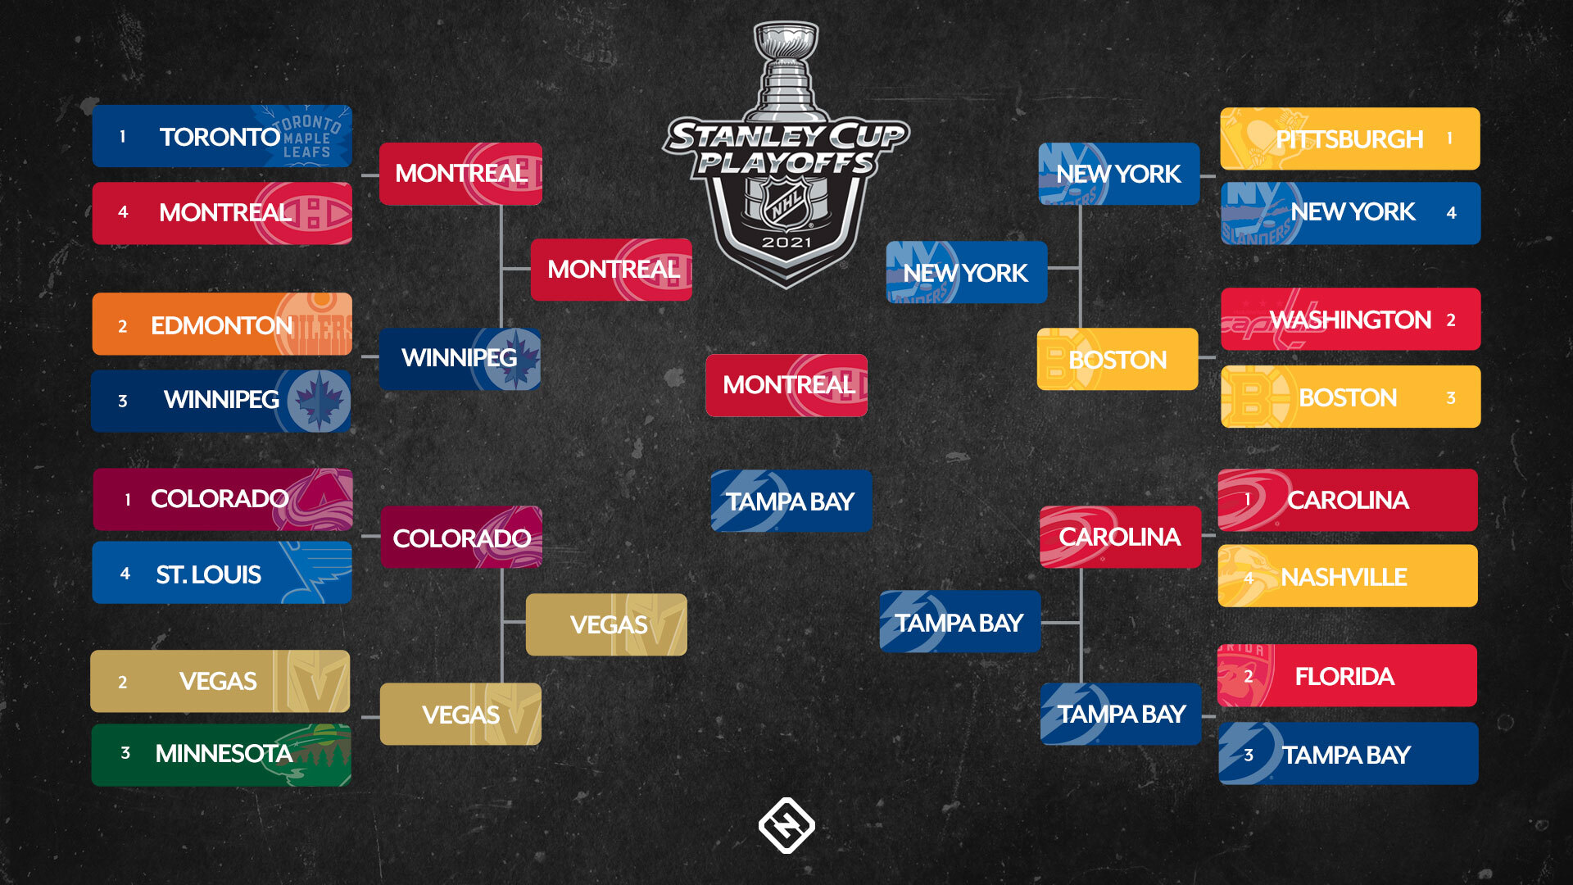

*2021 Stanley Cup Playoffs*

## Player stats

Over the course of a single **season**, each player has a variety of statistics accumulated over the course of the season. These are reset every season, and separate metrics are also tracked over the course of the **playoffs** for each **season**. Here is a sample of the top 3 players from the Montreal Canadiens over the 2020-2021 **regular season**:

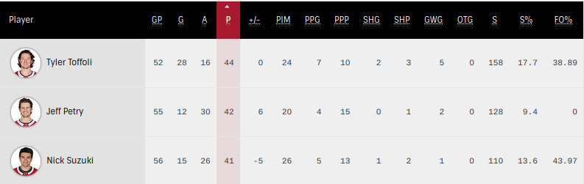

* **GP**: Games played (typically a max of 82, some seasons have less due to extenuating circumstances like say a pandemic). Players may play less than the max due to injury or being a **scratch** (sitting out of a game).
* **G**: Goals
* **A**: Assists
* **P**: Points (the sum of goals and assists, i.e. **G + A**)
* **+/-**: Plus/minus metric (calculated by taking the difference between the number of goals their team scored and the number of goals the opposing team scored while the player is on the ice)
* **PIM**: Penalty minutes (the number of penalty minutes this player has served)
* **PPG**: Power play goals
* **PPP**: Power play points
* **SHG**: Short handed goals
* **SHP**: Short handed points
* **GWG**: Game winning goals (the goal that would break a tie between the two teams; i.e. if the final score is 3-2, the player who scored the third goal is awarded with the game winning goal. However if the score is 5-0, the player who scored the first goal is credited with the game winning goal).
* **OTG**: Overtime goals
* **S**: Total number of shots on goal
* **S%**: Scoring percentage (calculated as the ratio of **G**/**S**)
* **FO%**: Faceoff percentage (the percentage of faceoffs won)

**Goaltenders** have a slightly different statline. Consider the **goalies** for the Montreal Canadiens over the same 2020-2021 **regular season**: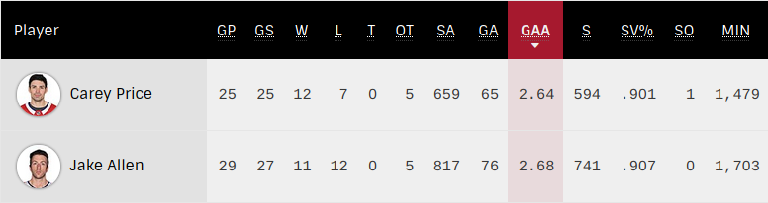

* **GP:** Games played (typically much lower than the full length of a season as goalies tend to require nights off)
* **GS:** Games started, i.e. began the game as the **starting goalie** (this could be less than GPif the goalie replaced the other starting goalie during some of the games)
* **W**: Number of games won
* **L**: Number of games lost
* **T:** I have no idea why this is here honestly
* **OT**: Overtime losses (i.e. made it to overtime, but lost)
* **SA**: Shots against (total shots faced)
* **GA:** Goals against (total goals let in)
* **GAA**: Goals against average (number of goals allowed per 60 minutes of playing time; calculated by multiplying the goals against by 60 (minutes), and dividing by the number of minutes played)
* **S:** Saves
* **SV%**: Save percentage (saves divided by shots against)
* **SO:** Shutouts (games where the goalie did not let in a single goal)
* **MIN:** Total number of minutes the goalie played during a season.

# Useful References

1. [Unofficial NHL API Documentation](https://gitlab.com/dword4/nhlapi)
2. [Ice Hockey Rules Explained | Ice Hockey 101 - Chicago Wolves](https://www.chicagowolves.com/gameday/hockey-101/explanation-of-common-rules/)